# Red Torque – Detailed Major Component Study

Date: 03 August 2025

## Raspberry Pi 5

The Raspberry Pi 5 is the latest and most powerful version of the Raspberry Pi computer series. It looks like a small board but has the power of a full desktop. It is made for DIY and educational projects, especially robotics.

In our robot project, it will be the main brain handling image processing, decision-making, and controlling other components.

* Quad-core 64-bit ARM Cortex-A76 CPU running at 2.4GHz – faster than Pi 4.
* Dual camera ports – supports two camera modules at the same time.
* PCIe 2.0 interface – allows fast SSD storage or expansion cards.
* Real-time clock – keeps track of time even without power.
* Improved GPIO performance – faster and better I/O for sensors.
* Supports active cooling via fan connector directly on board.
* USB 3.0 ports – faster data transfer from external devices.
* Used as the main controller to run Linux (Raspberry Pi OS).

The Raspberry Pi 5 acts as the main brain of the robot, handling tasks like image processing, sensor integration, and decision-making. It runs the software that controls movement, processes camera input, and communicates with other modules like the ESP32.

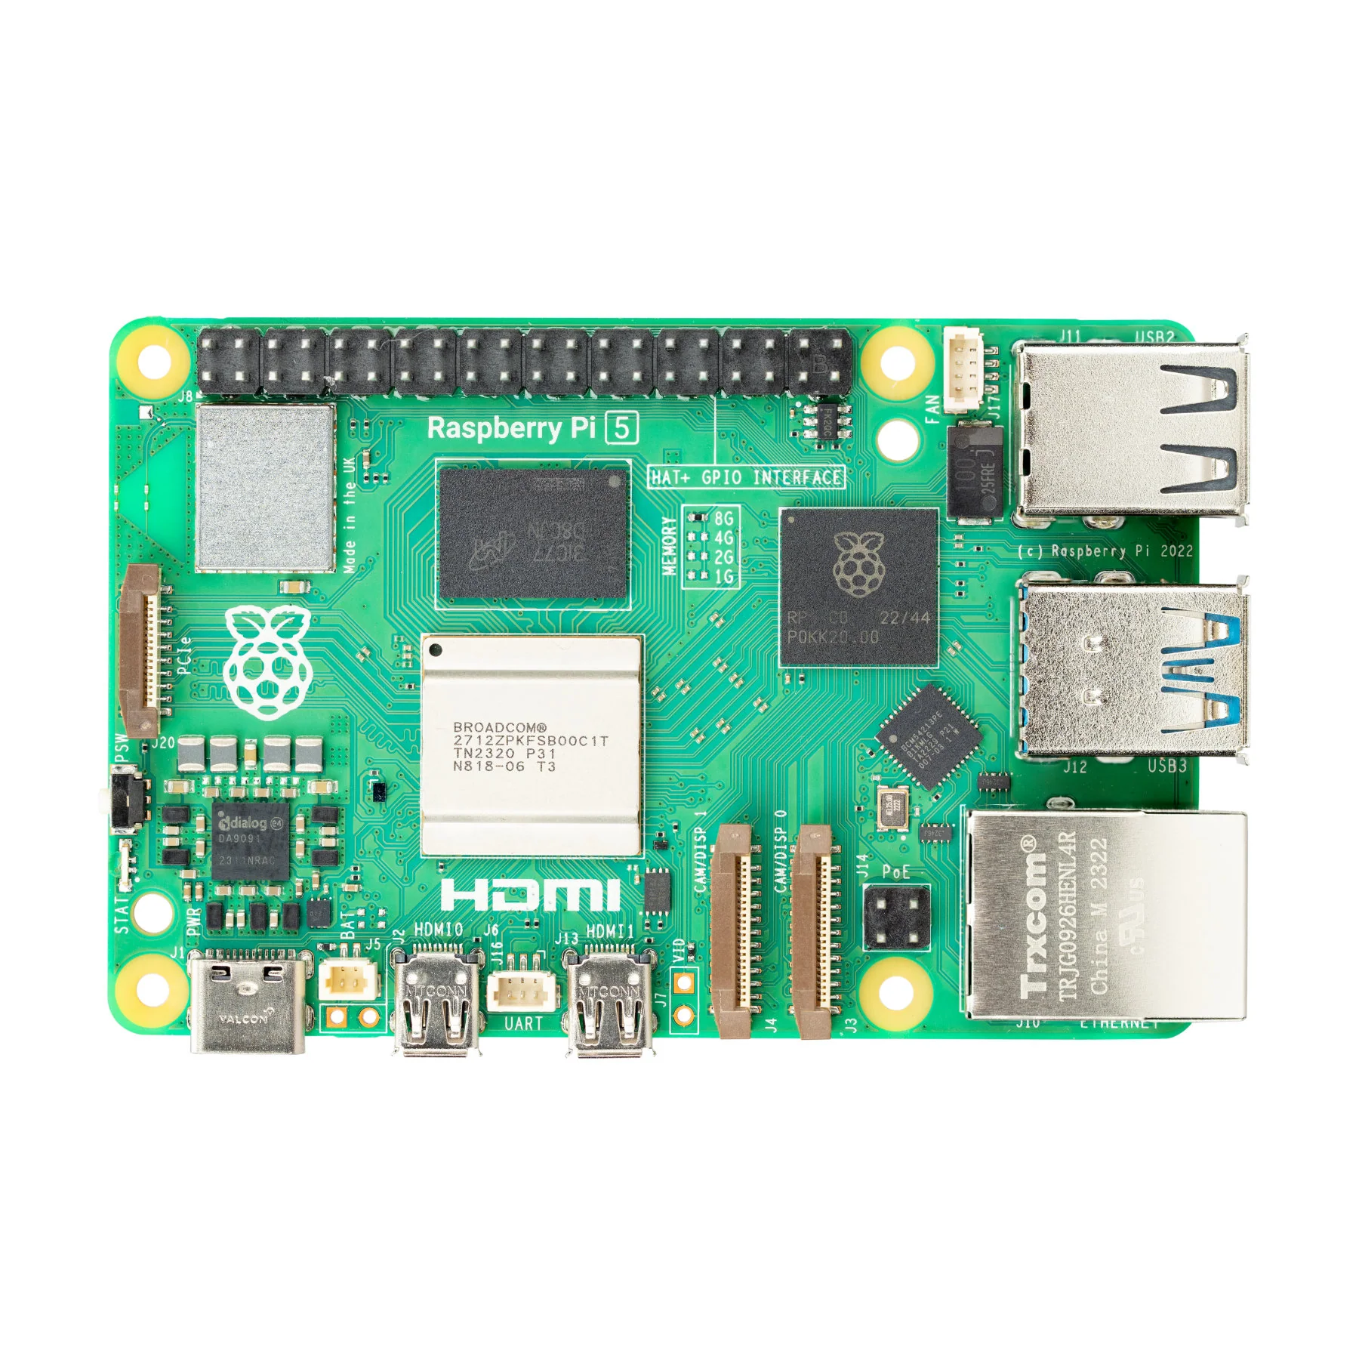

## 2. Raspberry Pi Camera Module V2

The Pi Camera V2 is an 8-megapixel camera designed to work directly with the Raspberry Pi using the CSI port. It is small, lightweight, and provides good video quality for computer vision applications.

* Sony IMX219 image sensor with 8 MP resolution.
* Can shoot 1080p video at 30fps, 720p at 60fps, and 640x480p at 90fps.
* Connects to Pi using a flat ribbon cable via CSI port.
* Low latency image capture – good for real-time detection.
* Compatible with Python libraries like OpenCV and Pi Camera.
* Used in our robot to detect red and green cubes and perform line following.

The Pi Camera V2 captures high-quality images and videos for computer vision tasks.

It’s mainly used to detect objects, recognize colours or shapes, and track movement

helping the Raspberry Pi understand and respond to the robot’s surroundings in real time.

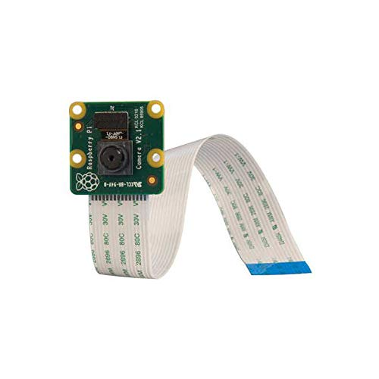

Pi Cam V2

## 3. ESP32 Microcontroller

The ESP32 is a low-cost, low-power microcontroller board that includes built-in Wi-Fi and Bluetooth. It is popular in IoT and robotics projects.

* Dual-core processor with speeds up to 240 MHz.
* Wi-Fi and Bluetooth capabilities make it suitable for wireless communication.
* Can be programmed using Arduino IDE or MicroPython.
* Multiple GPIO pins to connect sensors and control motors.
* I2C, SPI, UART interfaces for communication with other boards and modules.
* In our project, used as a helper board to offload simple sensor readings or Bluetooth tasks.

The ESP32 is used for handling low-level tasks like motor control, reading sensor data, and wireless communication (Bluetooth or Wi-Fi). It works alongside the Raspberry Pi to offload real-time processing and ensures smooth coordination between hardware components in the robot.

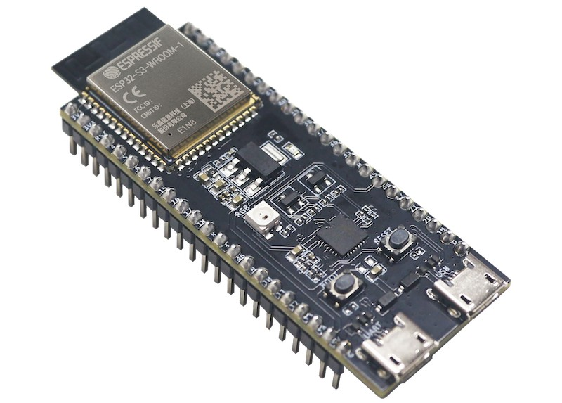

ESP-32

## 4. IMU-(Accelerometer & Gyroscope)

The MPU-6050 is an Inertial Measurement Unit (IMU) sensor that includes a 3-axis accelerometer and a 3-axis gyroscope. This sensor is used to detect motion, tilt, orientation, and vibration.

* Measures acceleration in X, Y, Z axes (movement detection).
* Measures angular velocity – tells us how fast something is turning.
* Communicates with Pi or ESP32 using I2C protocol.
* Used in smartphones, drones, and robots for orientation control.
* In our robot, helps detect tilt, balance, or sharp turns.
* Compact and easy to integrate on a breadboard or chassis.

The MPU-6050 measures motion, orientation, and rotation using its built-in accelerometer

and gyroscope. In our robot, it helps detect tilts, turns, and balance, allowing the system to

understand movement changes and adjust driving behavior or navigation accordingly.

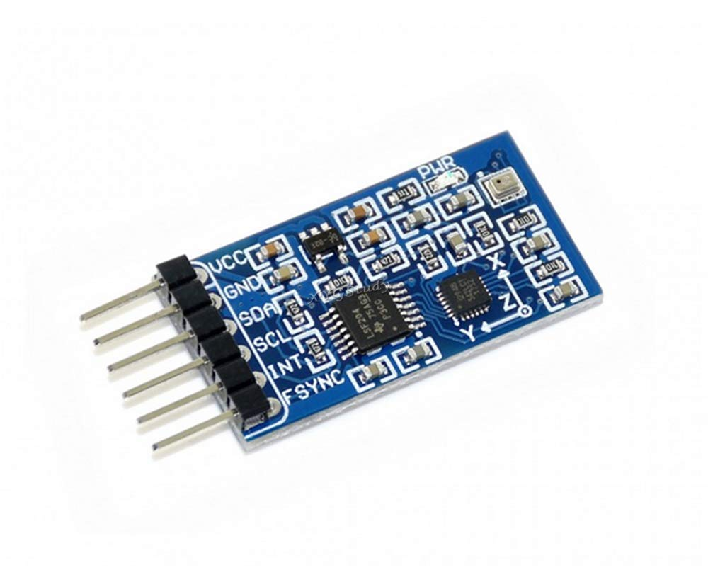

MPU-6050

## 5. Buck Converter & USB Buck

A buck converter is a voltage step-down converter that changes a high input voltage to a lower output voltage. It is crucial for safely powering electronics from batteries.

* Converts 11.1V from battery to 5V or 3.3V for Raspberry Pi and ESP32.
* Some models come with USB output for easy powering of USB devices.
* Adjustable voltage using a screw trimmer.
* Ensures consistent and safe voltage levels to prevent board damage.
* Two types used: standard screw terminal buck and USB buck module.

The buck converter steps down the high voltage from the battery (like 12V) to a lower voltage (like 5V) needed by the Raspberry Pi and other components. The USB buck converter does the same but gives output through a USB port, making it easier to power boards like the Pi or ESP32 directly.

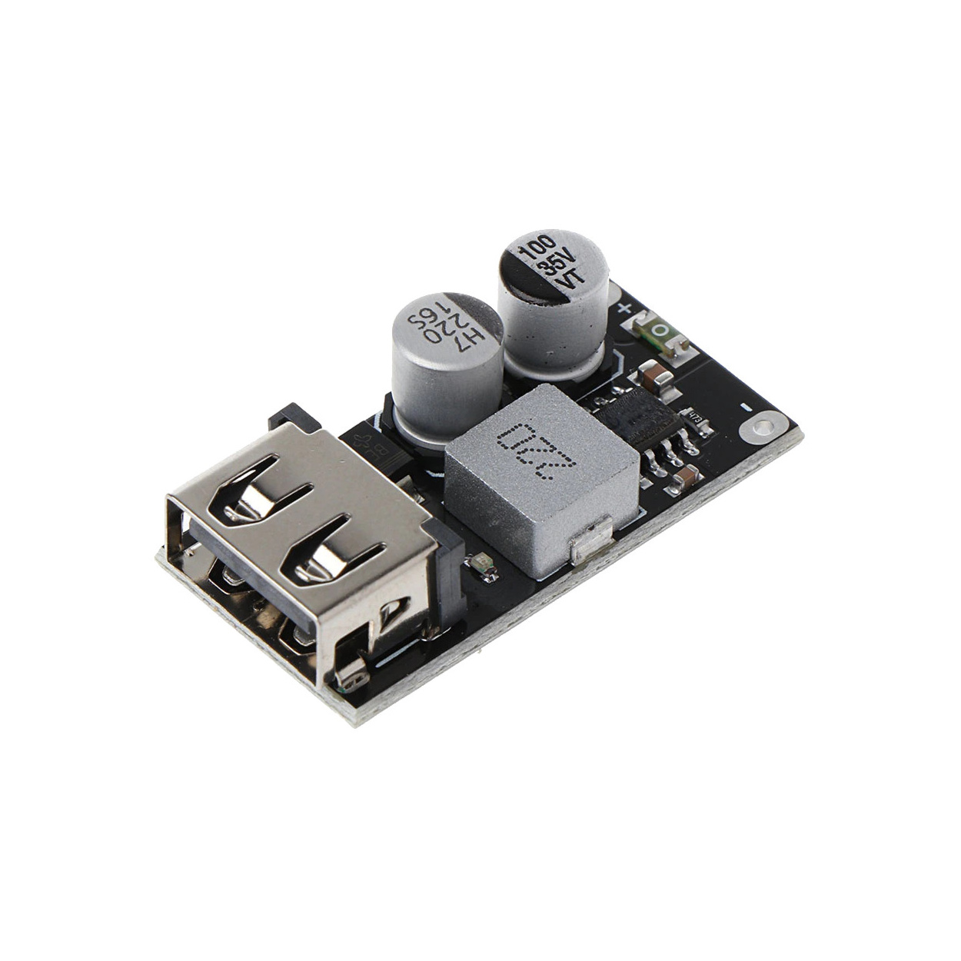 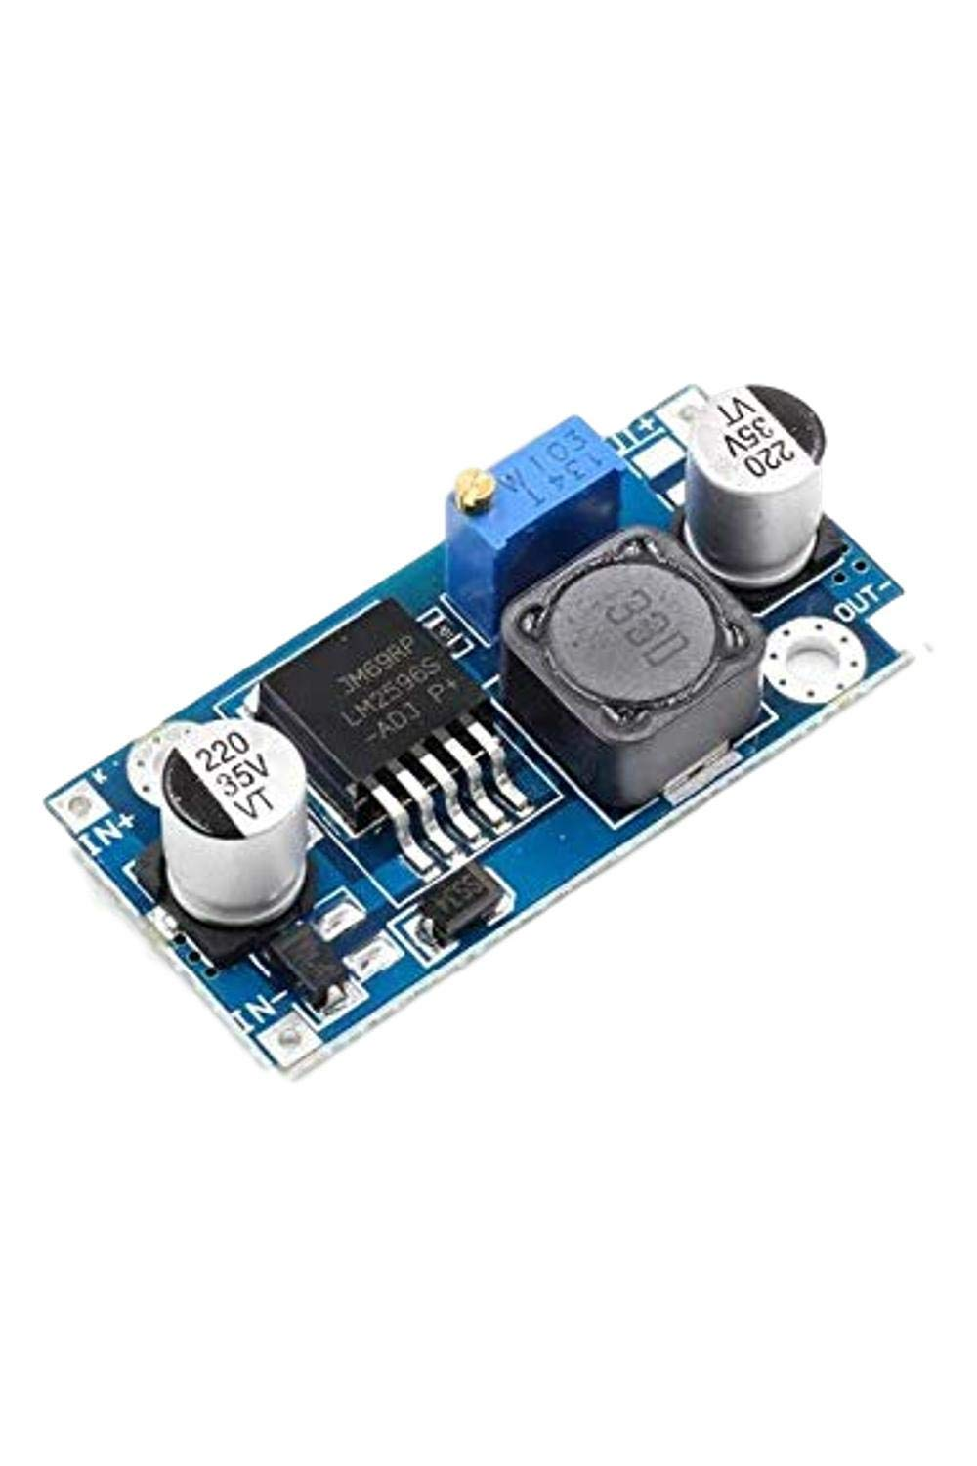

**USB BUCK CONVERTER DC-DC BUCK CONVERTER**

## 6. Bonka 11.1v LiPo Battery

This is a high-performance LiPo battery often used in drones and RC cars. It provides 11.1V output and has a discharge capacity suited for robotics.

* 3-cell LiPo battery giving a total of 11.1V.
* 2200mAh capacity – can power the robot for a decent amount of time.
* XT-60 connector for strong, secure connection.
* Used with a buck converter to deliver 5V to our components.
* Must be handled with care – requires balanced charging.
* Compact size – easy to mount on the chassis.

The 2200mAh LiPo battery provides portable, high-current power for the entire robot

system. It supplies energy to the Raspberry Pi, motors, sensors, and other modules. Its high

discharge rate and lightweight design make it ideal for mobile robotic applications where

stable power is essential.

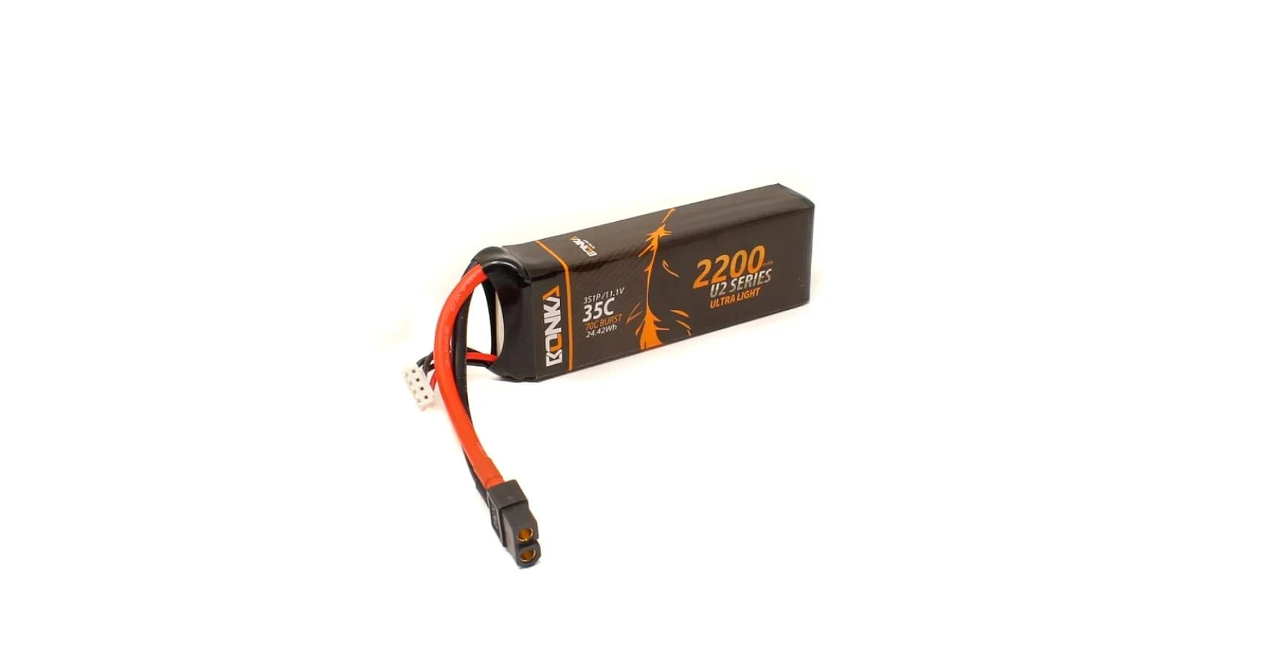

Bonka 11.1V 2200 Mah Battery

## Summary

The core components explored include the Raspberry Pi 5, which functions as the main processor responsible for handling computation and data processing. The Pi Camera V2 is used for capturing high-quality images and video, making it suitable for vision-based tasks. The ESP32 microcontroller provides wireless connectivity through Wi-Fi and Bluetooth and supports multiple I/O functions for flexible hardware interfacing.

The MPU-6050 sensor offers 6-axis motion tracking by combining a 3-axis accelerometer and a 3-axis gyroscope, useful for detecting tilt, rotation, and orientation. A 2200mAh LiPo battery serves as the main power source, supplying energy to all components. Voltage regulation is managed through a buck converter and a USB buck converter, which safely step-down higher voltage to levels required by sensitive electronics.

Each component plays a vital role in building a stable and efficient electronic system. Their individual functions and purposes are clearly identified and will be used collectively in the system’s design and integration.